**EXPERIMENT 4**

**IMPLEMENTATION:**

**MONGODB**

Checking the version

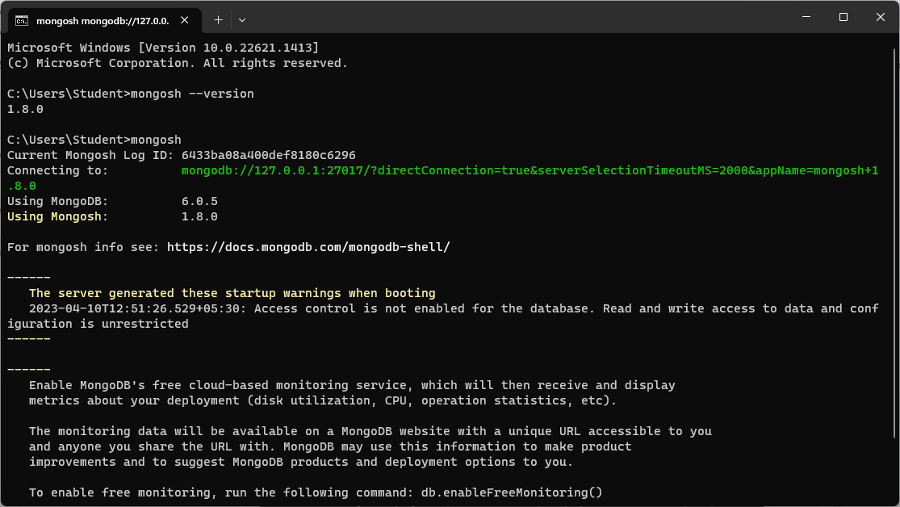

Show all the databases

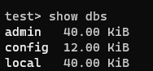

Create a new database if already does not exist



Create a new collection



Show all the collections existing



INSERT OPERATION

1. Insert one

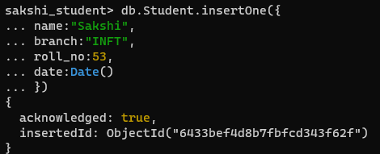

1. Insert many

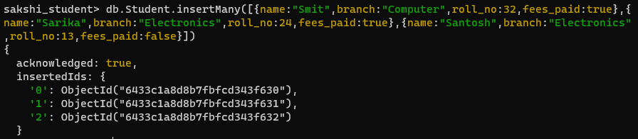

SEARCH OPERATION

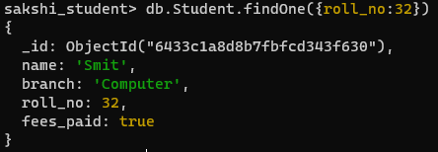

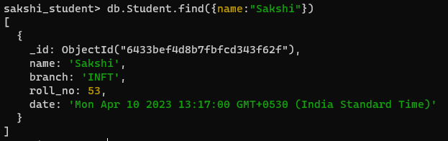

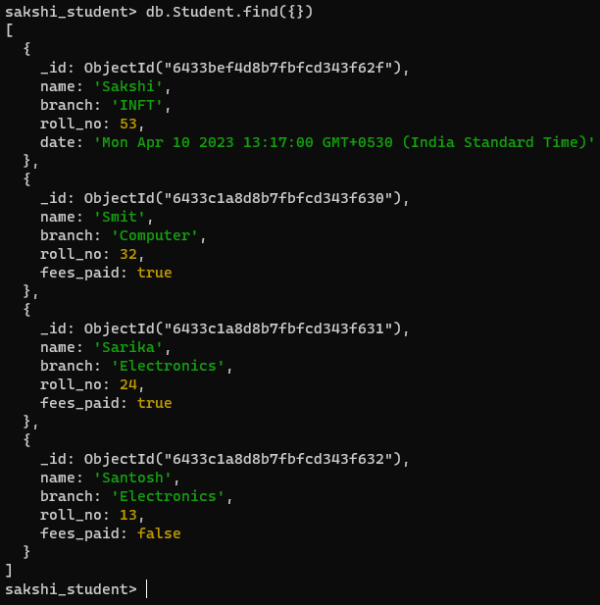

DELETE

1. Delete one



1. Delete many

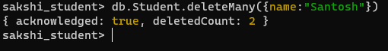

**RESTFUL API USING MONGODB**

1. Initialize NodeJs project with npm init

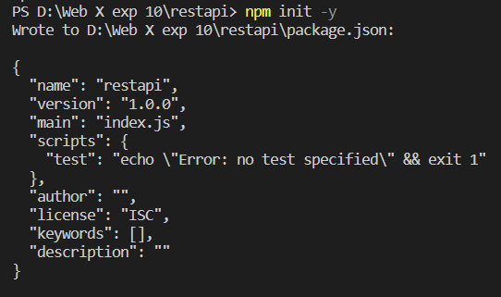

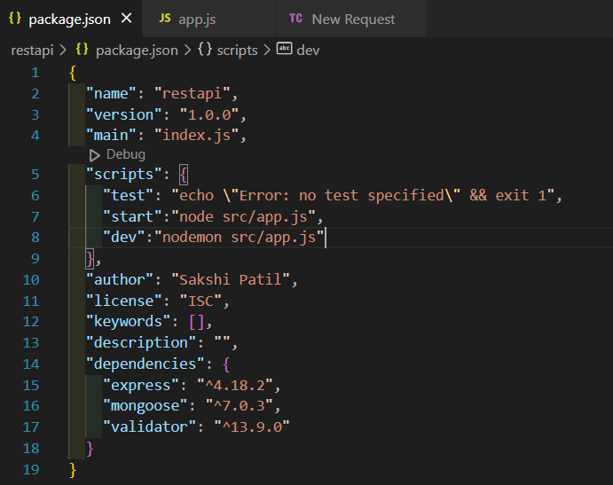

Now to run the project: npm run dev

1. Installation:
2. npm i express
3. npm i mongoose
4. npm i validator
5. npm install -g nodemon
6. npm i body-parser
7. Make a directory src and add a file app.js in it.

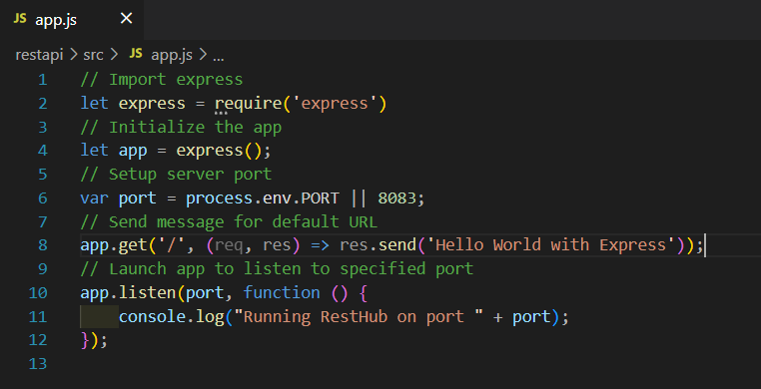

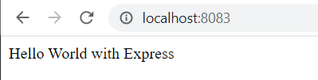

1. Create a folder db in src with connection.js

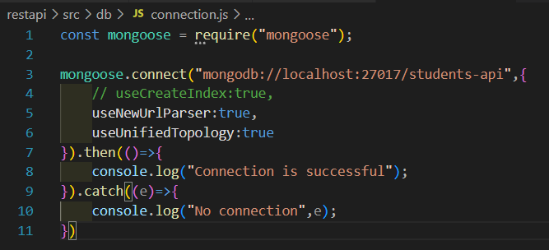

Require this file in app.js



Connection established

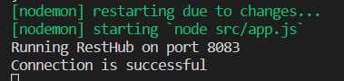

1. Create a schema for your database

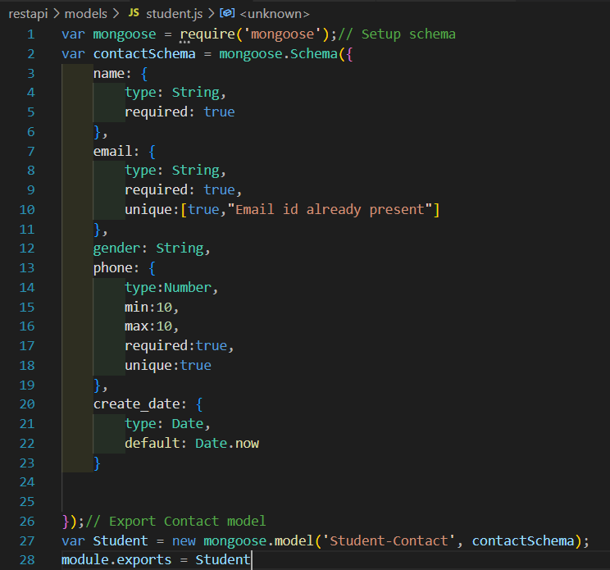

Require it in app.js



1. The database and its collection will be created in Mongodb if not already present

